Lab task 01

Question 01:
Command:
mkdir nazish ishfaq-f2024332112
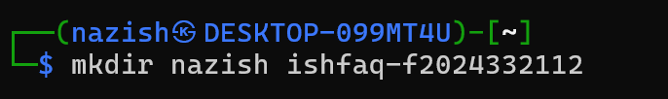

Question 02:
Command:
mkdir -p nazish ishfaq-f2024332112/folder1/folder2/folder3/folder4/folder5

Question 03:
Command:
ls -R
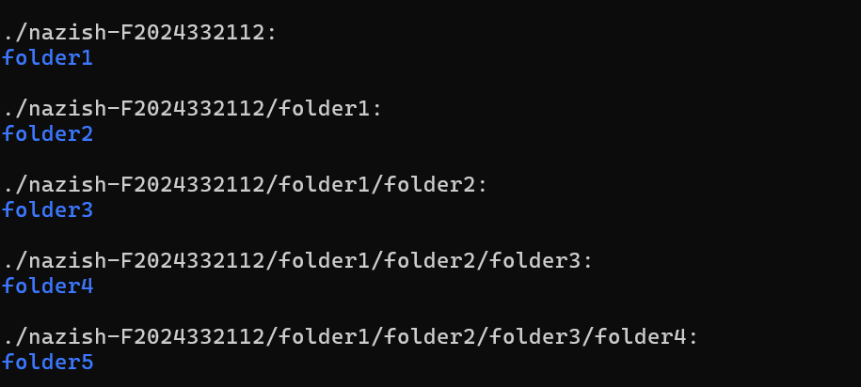

Question 04:
Command:
nano nazish-F2024332112/intro.txt
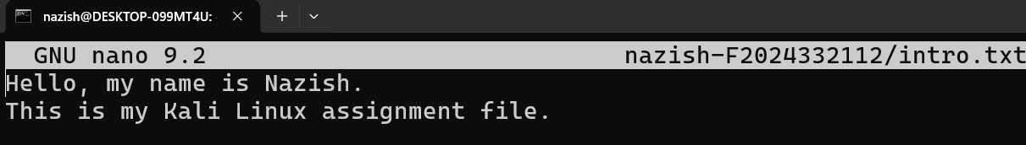

Question 05:
Command:
cat nazish-F2024332112/intro.txt

